# Project Description

A subscriber sends subscription request to the broker for a food topic. The publisher stores the subscriber info along with its subscription topic in the database. Publisher periodically pulls data from public API’s and sends to the broker. Whenever the publisher pushes the data, the broker filters the data based on the subscribed topic and sends the data to the relevant subscribers.

# Architectural Diagram:

# Flow Char for subscribing:

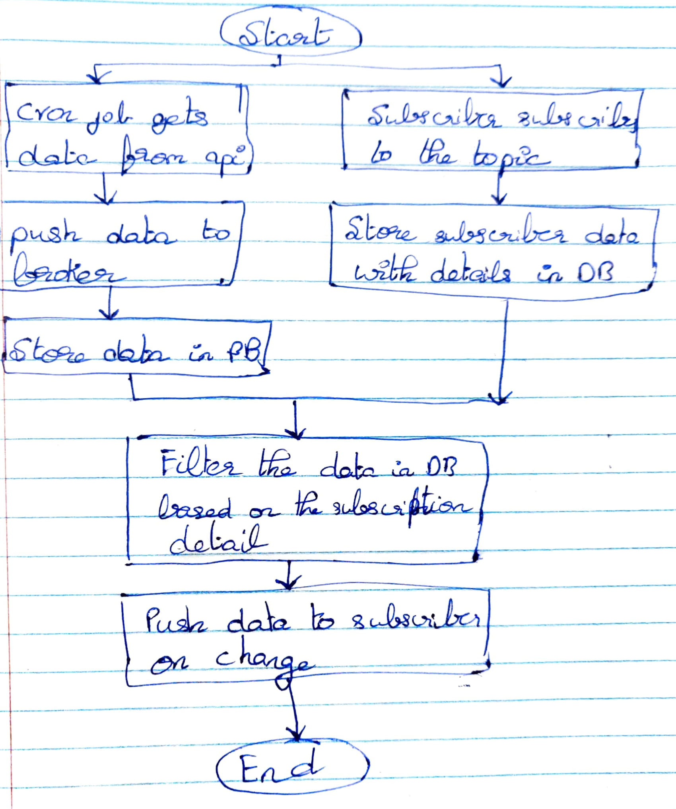

# Flow chart for unsubscribing:

# **CONTAINER DESCRIPTION:**

1. **PUBLISHER** - Gets Data from public API and pushes the value to the broker
2. **BROKER** - Collects data from publishers and stores in the Database. Handles subscription and un-subscription request from the subscriber. Based on the subscriber’s subscription preference brokers filters the publisher’s data and sends to the client.
3. **SUBSCRIBER** – Informs broker about its subscription preferences. Displays the data fetched from the broker

**DATABASE** :  
  
Subscription Details:

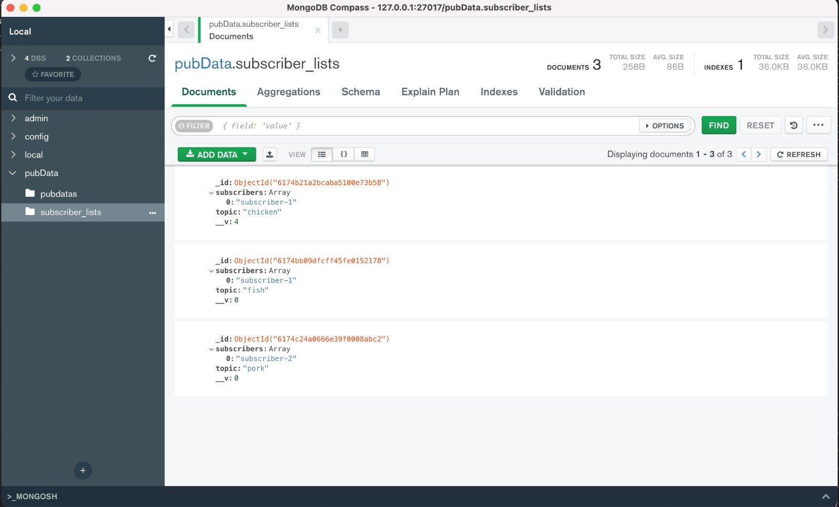

Publisher data:

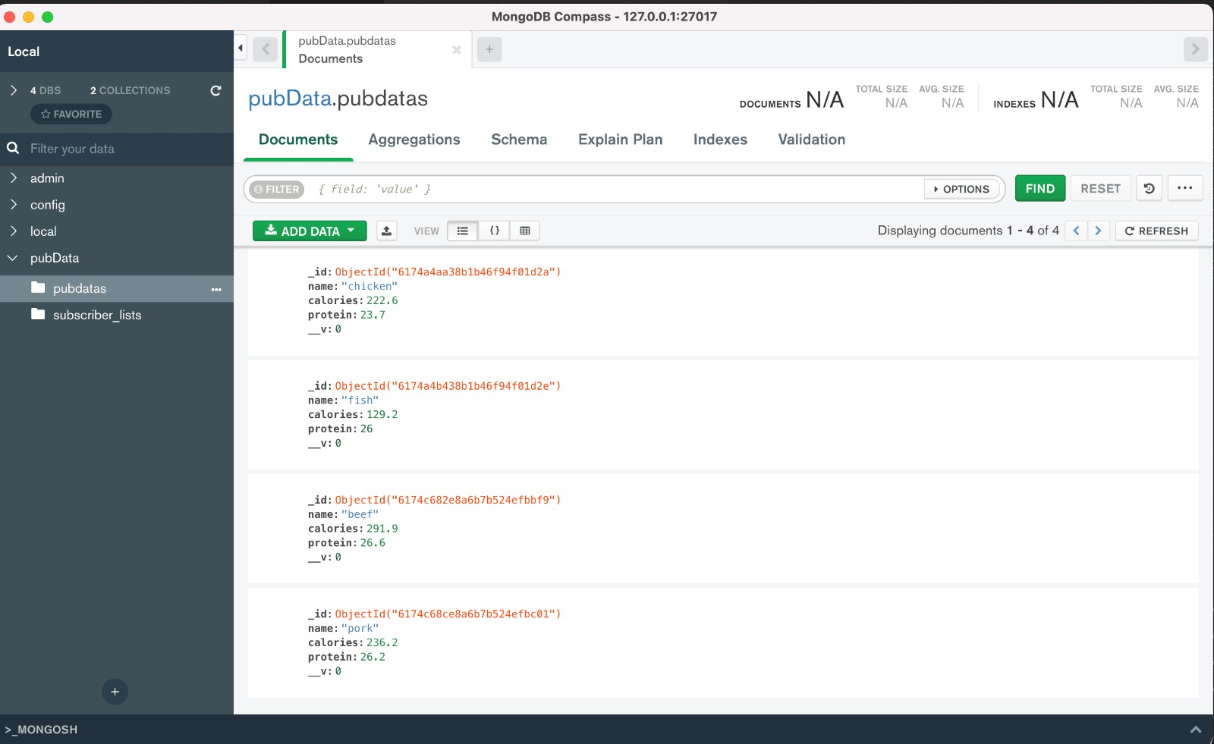

**WORKING** **OF** **THE** **PROJECT**:`  
  
